Module 3 (Task 4)

Task A (Archive Procedure): Create a conceptual Stored Procedure ArchiveOldLoans that moves loans older than 2 years to a History_Loans table.
First Created history_order table:-
CREATE TABLE history_orders (
order_id INT PRIMARY KEY,
user_id INT NOT NULL,
address_id INT NOT NULL,
total_amount NUMERIC(12, 2) NOT NULL,
status VARCHAR(20),
payment_method VARCHAR(30),
payment_status VARCHAR(20),
created_at TIMESTAMP NOT NULL,
archived_at TIMESTAMP NOT NULL DEFAULT NOW()
);
Then Created Procedure :-
CREATE OR REPLACE PROCEDURE archive_old_orders()
LANGUAGE plpgsql
AS $$
BEGIN

INSERT INTO history_orders (
order_id,
user_id,
address_id,
total_amount,
status,
payment_method,
payment_status,
created_at,
archived_at
)
SELECT
order_id,
user_id,
address_id,
total_amount,
status,
payment_method,
payment_status,
created_at,
NOW()
FROM orders
WHERE created_at < NOW() - INTERVAL '2 years';

DELETE FROM orders
WHERE created_at < NOW() - INTERVAL '2 years';
END;
$$;
And Last Call this archive_old_orders:-
CALL archive_old_orders();

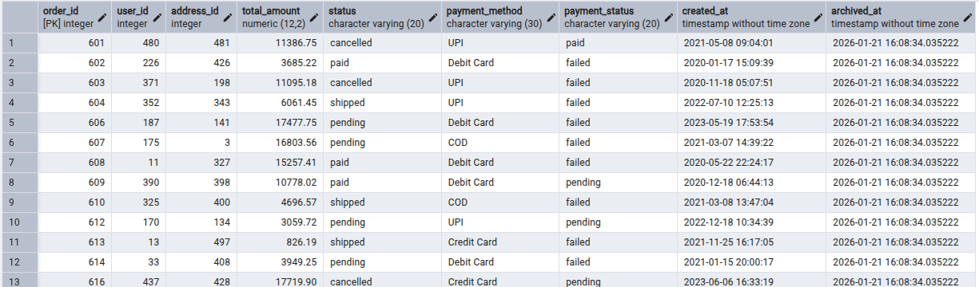

Task B (Views): Create a View ActiveMemberSummary that shows Member Name and Total Books Borrowed, hiding the underlying ID complexity.
First Created View :-
CREATE OR REPLACE VIEW ActiveCustomerOrderSummary AS
SELECT
u.username AS customer_name,
COUNT(o.order_id) AS total_orders,
COALESCE(SUM(o.total_amount), 0) AS total_amount_spent
FROM users u
JOIN orders o
ON u.user_id = o.user_id
WHERE u.is_active = 'true'
GROUP BY u.username;

Now fetch data from ActiveCustomerOrderSummary table:-
